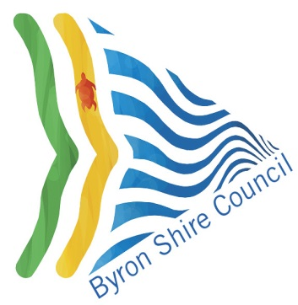

#E2019/87063

BSC File No: 26.2019.7.1

Contact: Rob van Iersel

28 November 2019

Department of Planning & Environment

Locked Bag 9022

GRAFTON NSW 2460

By Email: [northcoast@planning.nsw.gov.au](mailto:northcoast@planning.nsw.gov.au)

Dear Sir/Madam

**Planning Proposal to amend Byron LEP 2014 – former Byron Bay** **Hospital Site**

Council at its Planning Meeting of 20 September 2018 resolved (Res 19-561):

1. *That Council forward the planning proposal for the former Byron Hospital site (Attachment 1 #E2019/78938) to the Department of Planning, Industry and Environment for Gateway Determination.*

*2. That the planning proposal be put on public exhibition in accordance with the Gateway Determination, and that Council receive a further report at the end of the exhibition period detailing submissions made.*

In accordance with Section 3.34 of the *Environmental Planning and Assessment Act 1979,* Council submits the enclosed planning proposal for a Gateway determination. Council requests delegated Authority to make the LEP amendment – please see below the completed delegation evaluation.

As the planning proposal is not considered to be ‘low impact’ as outlined in the Department of Planning and Infrastructure’s, *A guide to preparing local environmental plans*, a 28 day public exhibition period is recommended.

Should you have any enquiries please contact Rob van Iersel by phone (02) 6626 7054 or email [rvaniersel@byron.nsw.gov.au](mailto:rvaniersel@byron.nsw.gov.au)

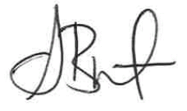Yours sincerely,

Shannon Burt

Director – Sustainable Environment and Economy

Enc. Evaluation criteria for the delegation of plan making functions - #E2018/79137

Planning Proposal 26.2017.6.1 - #E2018/78514

Council Report 20 September 2018 - #I2018/1175